**SPECIFIC REQUIREMENTS**

**Specific Requirements**

**1. External Interface Requirements:**

**1.1 User Interfaces:**

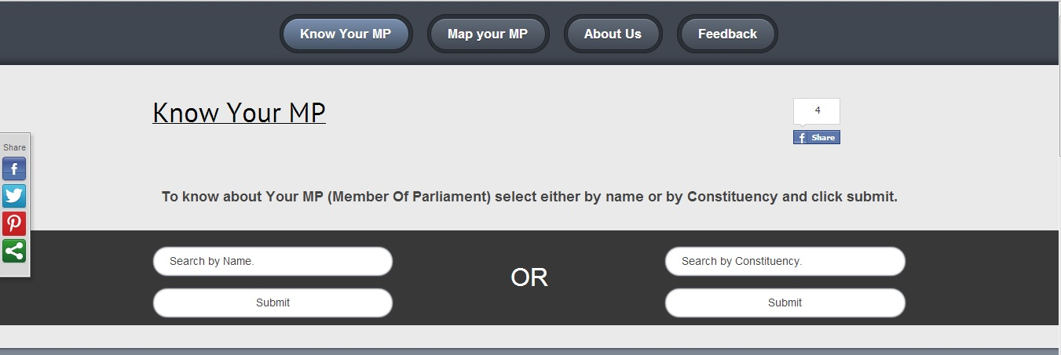

The user needs to select either the Name of the MP or by the name of the Constituency and click submit. The system will return back data of personal details and the Attendance status of respective search.

**1.2 Hardware Interface:**

The system needs the Standard minimum requirements as perthe Hardware is concerned.

**1.3 Software Interface:**

The system interfaces with database (phpmyadmin), Apache server and also with jquery and jscript libraries.

**1.4 Communication Interface:**

System asks only to enter the name of the MP or the name of the constituency.

It queries the input and show the result on the screen.